Solution one

There are a number of ways to detect vehicles, in this solution we will discuss a how inductive loop is used in Traffic light signal. Inductive loop vehicle detector system consists of three components: a loop, loop extension cable and a detector as shown if Fig1.

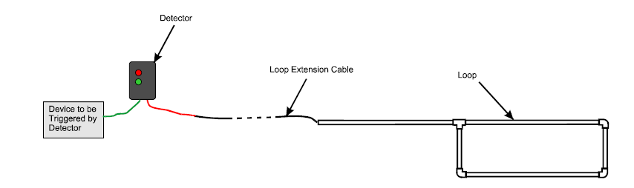
.

An inductive loop consists of wire “coiled” to form a loop that usually is a square, circle or rectangle shape that is installed into or under the surface of the roadway. Inductive loops work like a metal detector as they measure the change in the field when objects pass over them. Once a vehicle drives over a loop sensor the loop field change which allows the detection device to detect the presence of an object. Inductive loops are referred to as presence detectors and in traffic detection are often used in pairs to collect classification data such as speed data.
An induction loop is an electromagnetic communication or detection system which uses a moving magnet to induce an electrical current in a nearby wire. Induction loops are used for transmission and reception of communication signals, or for detection of metal objects in metal detectors or vehicle presence indicators.

Vehicle detection
Vehicle detection loops, called inductive-loop traffic detectors, can detect vehicles passing or arriving at a certain point, for instance approaching a traffic light or in motorway traffic. An insulated, electrically conducting loop is installed in the pavement. The electronics unit transmits energy into the wire loops at frequencies between 10 kHz to 200 kHz.

The inductive-loop system behaves as a tuned electrical circuit in which the loop wire and lead-in cable are the inductive elements. When a vehicle passes over the loop or is stopped within the loop, the vehicle induces eddy currents in the wire loops, which decrease their inductance. The decreased inductance actuates the electronics unit output relay or solid-state optically isolated output, which sends a pulse to the traffic signal controller signifying the passage or presence of a vehicle.

How it works:
The loop is buried in the traffic lane. The loop is a continuous run of wire that enters and exits from the same point. The two ends of the loop wire are connected to the loop extension cable, which in turn connects to the vehicle detector. The detector powers the loop causing a magnetic field in the loop area. The loop resonates at a constant frequency that the detector monitors. A base frequency is established when there is no vehicle over the loop. When a large metal object, such as a vehicle, moves over the loop, the resonate frequency increases. This increase in frequency is sensed and, depending on the design of the detector, forces a normally open relay to close. The relay will remain closed until the vehicle leaves the loop and the frequency returns to the base level. The relay can trigger traffic light.

Loop extension cable is used to extend the distance from the preformed loop to the vehicle detector, which is usually located indoors or in a weatherproof enclosure. The characteristics of the extension cable are just as important as the characteristics of the loop wire. Use only 14, 16, or 18 awg stranded 2 conductor twisted, shielded cable with a polyethylene insulation jacket. The distance between the loop and the detector can safely be extended to 300 feet with proper extension cable. Loop Vehicle Detector The proper installation and material is critical! In general, loop vehicle detectors from all manufacturers work under the same principle and will all work reliably if the installation is done properly and the correct materials are used.

After that signal conditioning circuit is used to pick up the change in the frequency by using a frequency to voltage converter. The LM331 is wired as a frequency to voltage converter which converts the input frequency into a proportional voltage which is extremely linear to the input frequency. The frequency to voltage conversion is attained by differentiating the input frequency using capacitor C3 and resistor R7 and feeding the resultant pulse train to the pin6 (threshold) of the IC. The negative going edge of the resultant pulse train at pin6 makes the built-in comparator circuit to trigger the timer circuit. At any instant, the current flowing out of the current output pin (pin 6) will be proportional to the input frequency and value of the timing components (R1 and C1). As a result a voltage (Vout) proportional to the input frequency (Fin) will be available across the load resistor R4.
For example if there is no car and the resonate it 10 KHZ and it there is a car the resonate will be 100KHZ
http://www.circuitstoday.com/frequency-to-voltage-converter-using-lm331

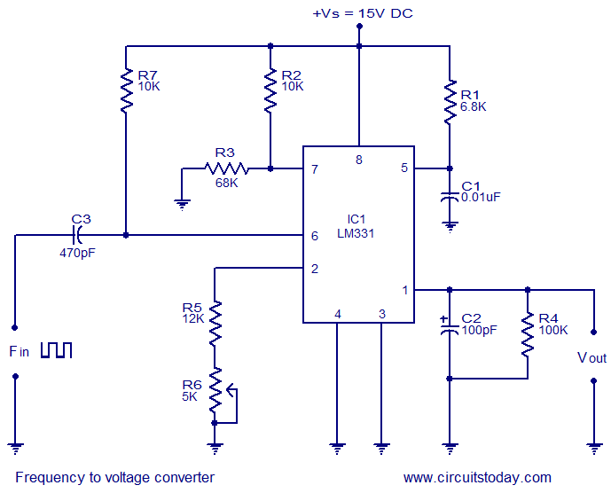
http://www.circuitstoday.com/frequency-to-voltage-converter-using-lm331

The Op-amp comparator compares one analogue voltage level with another analogue voltage level, or some preset reference voltage, VREF and produces an output signal based on this voltage comparison. In other words, the op-amp voltage comparator compares the magnitudes of two voltage inputs and determines which is the largest of the two.
The comparator will compare between the voltages to know if there is a car or not, If 10KHZ gives 1V and the reference voltage is 1 V too, then the output of the comparator will be zero and voltage will be produced. If it is higher it will give me positive and so on.

http://www.electronics-tutorials.ws/opamp/op-amp-comparator.html

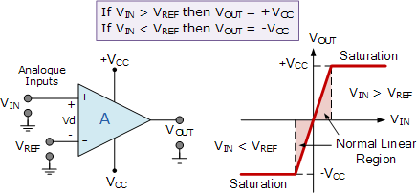

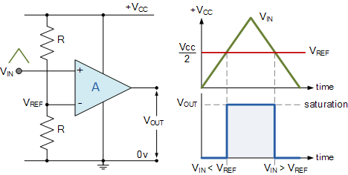

The comparator will produce a signal that will be sent to the microprocessor.
A 8085 microprocessor manipulates data in a computer system. The central processing unit acts as the brain of a computer and consists of one or more microprocessors made up of several thousand transistors on a single integrated circuit. The microprocessor works in conjunction with other parts of the computer to compute arithmetic and logic functions to handle tasks using an instruction set to perform all tasks within a computer.
The microprocessor accepts input from devices, such as a mouse, keyboard or scanner, and performs a function on that data. It makes a decision based on the data, the microprocessor computes the information and then it sends the results to the output devices.

Arithmetic Logic Unit

The arithmetic logic unit gathers information as input from the CPU registers and operands and then does the arithmetic operations (addition, subtraction, multiplication and division) and logic operations (AND, OR and XOR). During data processing, the ALU tests conditions and prepares to take different actions based on results. The ALU also gathers data from additional sources, including number systems, instructions, timing and data routing circuits, such as adders and subtracters.
Memory

The microprocessor accesses and stores binary instructions into memory, or circuits that store bits. Random access memory is a control memory that uses registers to temporarily store data. The microprocessor stores volatile data used by programs in RAM. Read-only memory stores data permanently on chips with instructions built in. It takes longer to access the information in ROM, but it does not lose information when a computer shuts down as does RAM.
Control Unit

The control unit directs the flow of operations and data by selecting one program statement at a time, interpreting it and sending messages to the ALU or registers to carry out the instruction. It also decides where to keep information in memory and which devices to communicate with by interfacing with the ALU, memory and input/output devices. The control unit can also shut down a computer if it or another device, such as the power source, detects abnormal conditions.

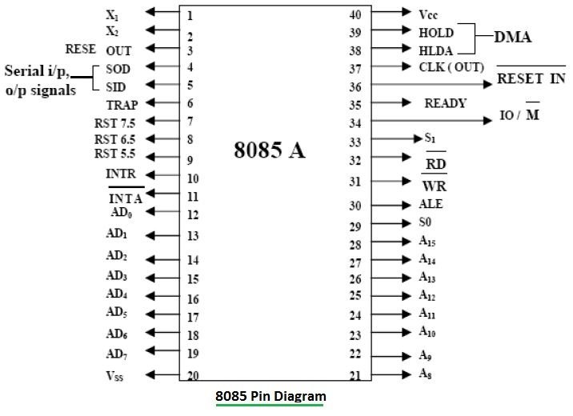

http://www.rfwireless-world.com/Tutorials/8085-microprocessor-architecture.html

The overall operation

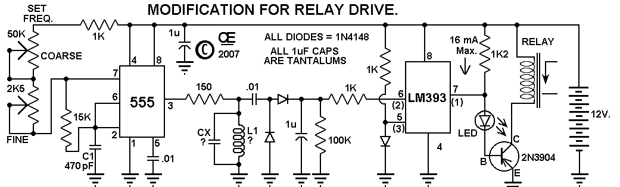
http://chemelec.com/Projects/Loop-Detector-1/Loop-Detector.htm

A square wave is produced from the 555 timer, flows to the 150 ohm resistor in a resonate frequency circuit that has a coil and a capacitor. Once pin 3 square wave output get resonated in the capacitor and inductor circuit .The frequency in the capacitor inductor circuit in coming from pin3 can be adjusted using a potential meters, the Dc is blocked allowing only the AC to pass. The AC is converted through the rectifier to DC, then it will flow to pin 6. When a large iron object passes over the loop the voltage will drop. When the voltage is dropped lower than the reference voltage on pin 5, pin 7 will no longer be grounded allowing the full current to flow in to base of the transistor activating the relay .
A delay of circuit to delay the time passing, instead of going ON and OFF, we can have a time frame where it will stay ON after a vehicle has passed over the coil triggering the circuit.

https://www.youtube.com/watch?v=MQTHcKgDRto

Advantages
inductive loop technology is the most reliable.
Increasing the number of turns increases stability.
It is relatively simple to install and has a long shelf life .

Disadvantages
The deeper the loop the less sensitive the loop detection system.
inductive loops and detectors are sensitive to temperature.
If air pockets exist, the loop wire will move whenever the pavement vibrates and false detections will occur.
When installing or repairing an inductive loop system the smallest detail can mean the difference between reliable detection and an intermittent detection of vehicles. Therefore, attention to detail when installing or troubleshooting an inductive loop vehicle detection system is absolutely critical.

